## PRACTICAL TWO:ANALYSIS TOOLPAK OF MICROSOFT EXCEL (I)

Generate a random number of 5 variables and the corresponding data using the random number generation of Microsoft excel. Carry out the descriptive analysis of the data using the descriptive statistics of the Microsoft analysis tool pack.

STEP 1: Click on data on the menu bar, then click on data analysis, then click on random number generation.

STEP 2: On the page of random number generation input 5 in the box for number of variables

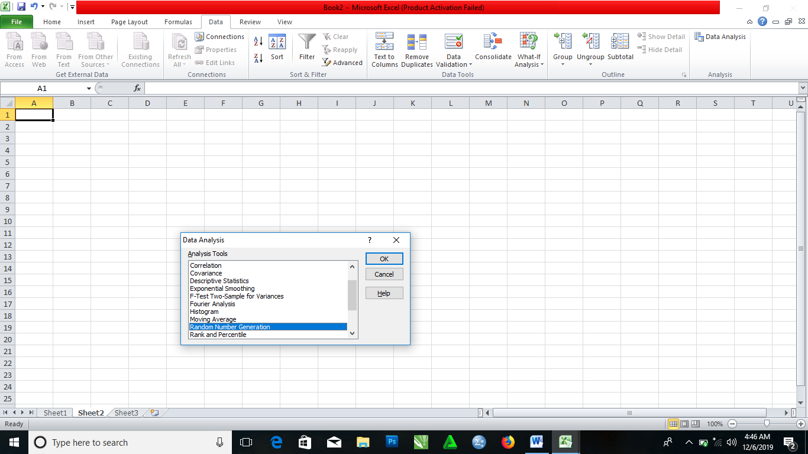

STEP 3: Put 20 in the Number of Random numbers to be generated box

STEP 4: Left click the Distribution to choose the distribution, then select Normal.

STEP 5: Left click the Output Range, then click where you want your result to appear on the spreadsheet

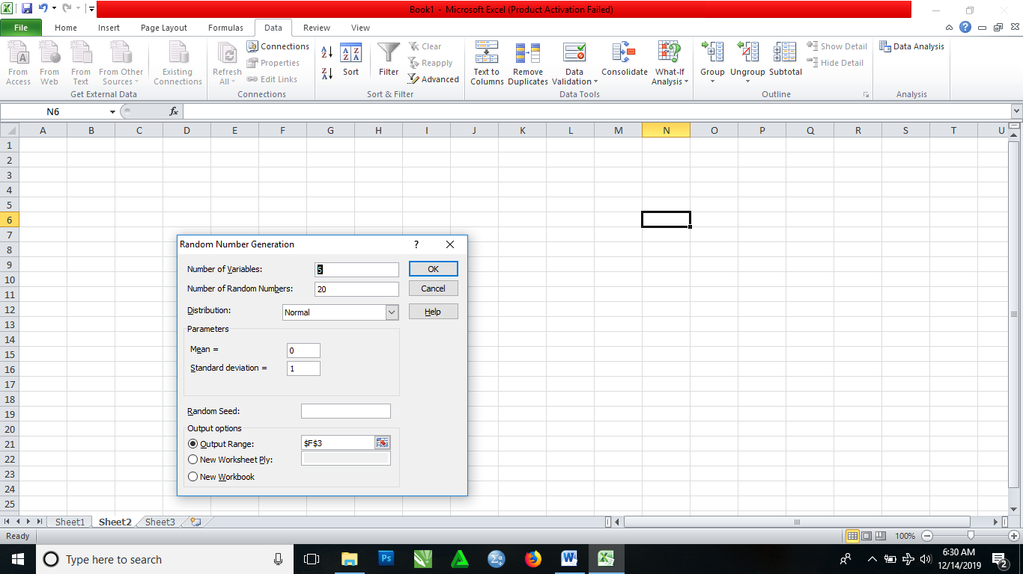

STEP 6: Click OK.

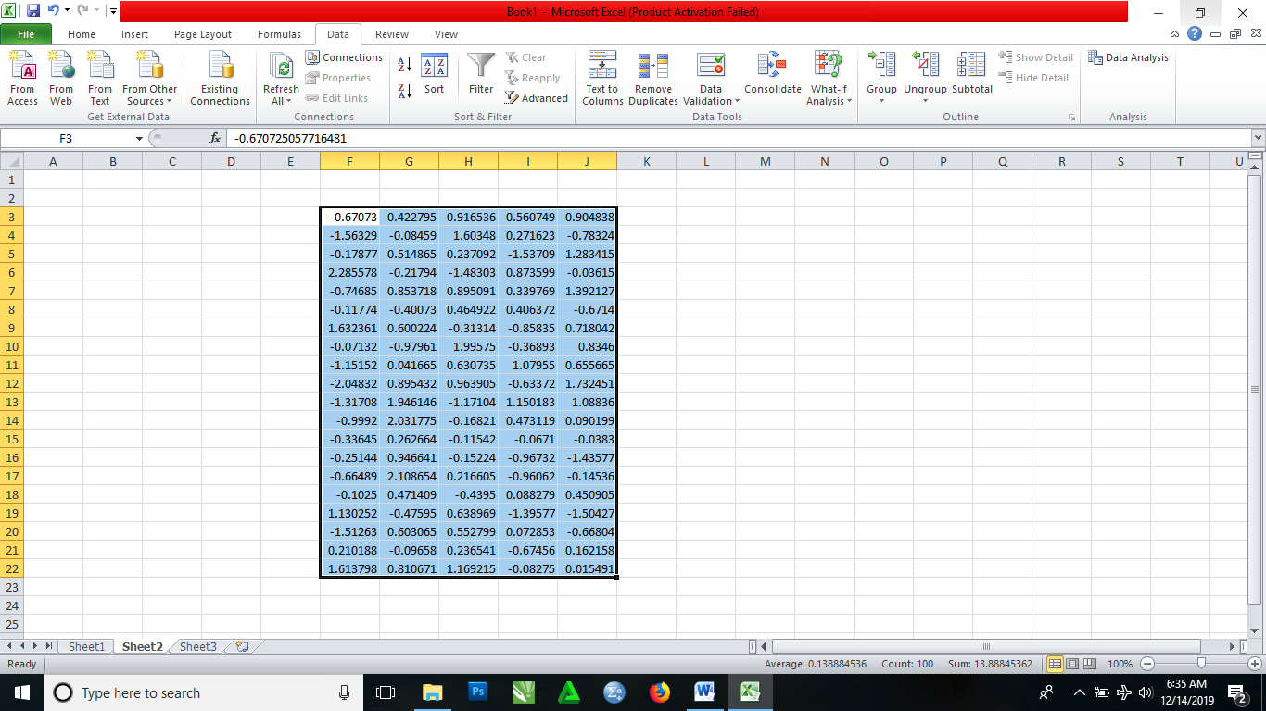

Carrying out the descriptive statistics of the generated random numbers.

Since, we are still working on Data. We follow the following steps to get the descriptive statistics:

STEP 1: Click on Data Analysis, then select Descriptive Statistics

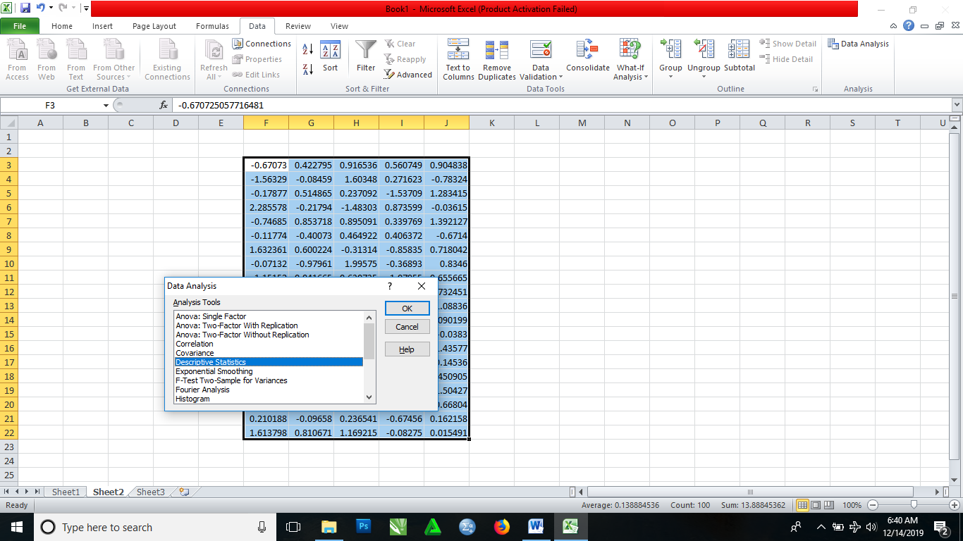

STEP 2: Click OK

STEP 3: Left click the Output Range to select the part of the part of the spreadsheet you want your answer to display.

STEP 4: Select Summary Statistics and Confidence Level for Mean (leave it at 95%)

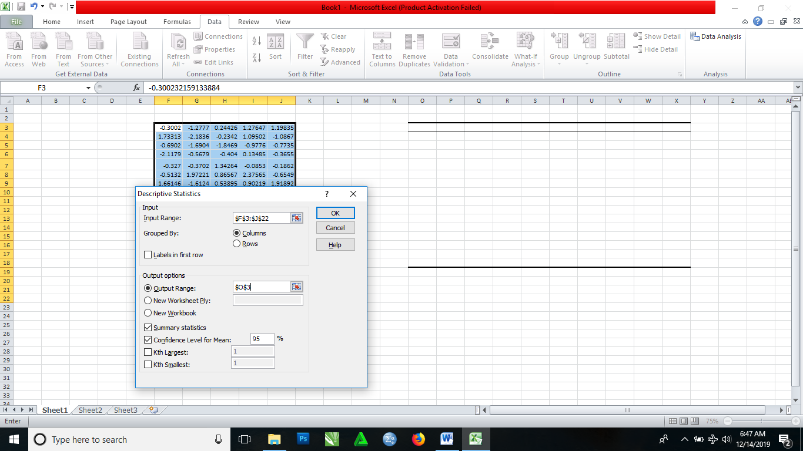

STEP 5: Click OK.

